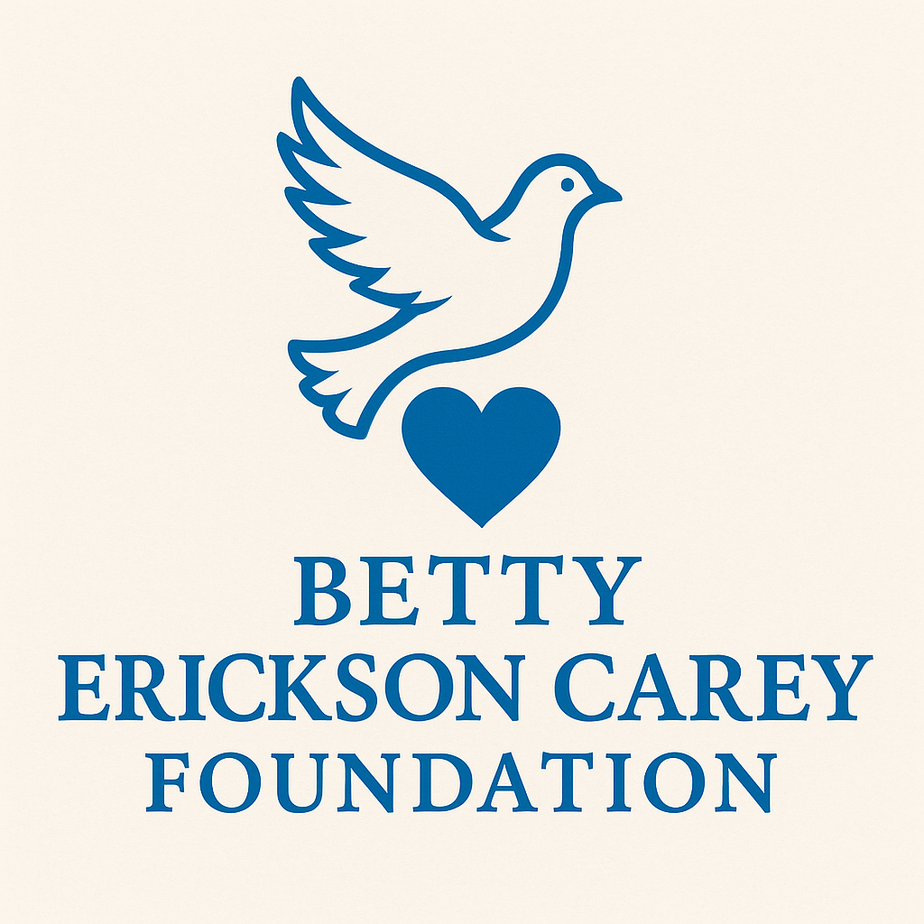
Meeting Agenda
Betty Erickson Carey Foundation
Board Meeting Agenda
Date: Wednesday, July 30, 2025,
Time: 4:30 PM
Location: Sports Pages, 102 E Railroad St, Sandwich, IL 60548
1. Call to Order
Led by the Chair or designated officer
2. Roll Call of Board Members
- Attendance and verification of quorum
- Quorum Requirement: 5 of 9 members
3. Approval of Agenda
Motion to approve the current agenda
4. Approval of Minutes
- Review and motion to approve July 15, 2025, Organizational Meeting Minutes
5. Old Business
- Scholarship Committee Setup
• Formalize members, define scope
- Payment Processing for Donations and Fundraising
• Compare platforms (Square, PayPal)
- Bill Pay Procedures
• Establish limits for board approval
- Liability Insurance Policy
• Review and vote
- CPR/Stop the Bleed Training
- Governance Clause – Family Legacy
- Golf Scramble Planning
6. Executive Officer Reports
- President
- Vice President
- Secretary-Treasurer (combined role)
7. Director & At-Large Member Reports
- Director of Community Engagement
- Director of Events
- Director of Partnerships
- Director of Outreach
- At-Large Members
8. Committee Reports
- Events
• Under the Big Top – Sept 25 @ 4PM
- Tent: $4,300 (Foundation share $2,150)
- Porta-potties shared with city
- All docs submitted to city
- Sign-Up Sheet needed
• National Night Out – Aug 5 @ 6–8PM
- Booth, items, 50/50 raffle
- Fundraising
• Vote on logo for t-shirts, koozies
- Scholarship
• Finalize application
- Finance/Audit
• Find CPA
- Outreach & Engagement
- Governance & Ethics
9. New Business
- Alzheimer’s Awareness Event – Sept 6
- Fiscal Year Planning (October proposed)
- Sponsorship Strategy
- Expenditure Threshold Policy
10. Public Comment (3 minutes per speaker)
11. Schedule Next Meeting
12. Adjournment

